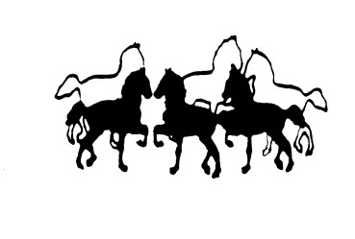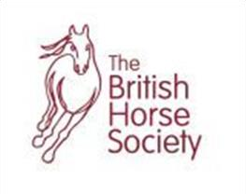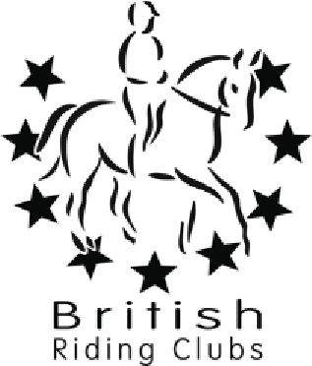

North Mymms Riding Club

Website : www.north
-
mymms
-
riding
-
club.co.uk

Affiliated To The BHS

Pole and Jumping Clinic with Helen Hawkins

BHS Stage 5 Coach. BHS Stage 4 Complete Horsemanship.

Spring Clinics at Warrenwood Manor Stud
Essendon AL9 6JF

Wednesday 21st February 2024 - starts midday until evening
Sunday 31st March (Easter Sunday) - starts approx. 9am
Sunday 19th May – starts approx. 9am

CLINIC WILL BE HELD IN INDOOR MENAGE

TIMES WILL BE GIVEN ONE WEEK BEFORE CLINIC

Option 1: Poles
Individual session for 30mins: £55pp (£43pp members rate)
2 people sharing for 1 hour: £55pp (£43pp members rate)
3 people sharing for 1 hour: £40pp (£30pp members rate)

Option 2: Jumping
Individual session for 30mins: £55pp (£43pp members rate)
2 people sharing for 1 hour: £55pp (£43pp members rate)
3 people sharing for 1 hour: £40pp (£30pp members rate)
Please state jump height preferred for individual rider/group.

Booking via: www.myridinglife.com/RemoteLocationEventList.aspx?SecretarylD= 479137
No refunds available unless clinic cancelled by instructor due to unforeseen circumstances.
All enquiries – phone/text Liz Kyriacos 07751445097 or email elizabethkyriacos@hotmail.co.uk

PLEASE CLEAN UP ALL DROPPINGS. NO RIDING IN OUTDOOR MENAGE.

