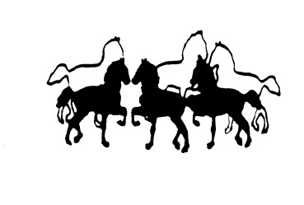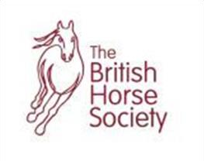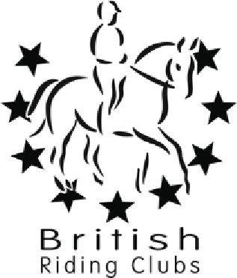

North Mymms Riding Club

Website : www.north
-
mymms
-
riding
-
club.co.uk

Affiliated To The BHS

Pole Clinic with Amanda Petts

BHS Accredited Professional Coach
Grand Prix British Dressage Rider and Trainer

Sunday 11th February and
Sunday 3rd March 2024

At Warrenwood Manor Stud
Hornbeam Lane
Essendon AL9 6JF

CLINIC WILL BE HELD IN INDOOR MENAGE
TIMES WILL BE TEXT ONE WEEK BEFORE CLINIC

Amanda specialises in pole work for performance, using poles to help improve the horses way of going, working on rhythm, balance, suppleness, straightness and impulsion. Encourage your horse to use their body in the best way possible, working on hoof eye co-ordination, riders balance, feel and accuracy, in a super fun way. A great clinic awaits you and your horse!

You will be grouped together based on level you are working at. Please select either:

OPTION 1: Very green – new to clinics. Very green or young horse/pony.
Up to 3 participants per group. 45minutes per session.
£33pp (£25pp members rate)

OPTION 2: Beginner – working towards prelim level
OPTION 3: Intermediate – working towards novice level
OPTION 4: Advanced – working at novice level or above

Options 2,3 and 4 - Up to 4 participants per group. 1hour per session.
£33pp (£25pp members rate)

Booking via: www.myridinglife.com/RemoteLocationEventList.aspx?SecretarylD= 479137
Please check Facebook Page, Website & your e-mails for upcoming clinics.
No refunds available unless clinic cancelled by instructor due to unforeseen circumstances.
All enquiries - phone Liz Kyriacos 07751445097 or email elizabethkyriacos@hotmail.co.uk
Please leave yard clean and tidy. All droppings to be picked up.

